Name: Abinash Satapathy
Reg. No.: 16BCE0081
Slot: L27 + L28

1. Command: cd
Desciption : Change to new directory
Syntax: cd Documents
Output:

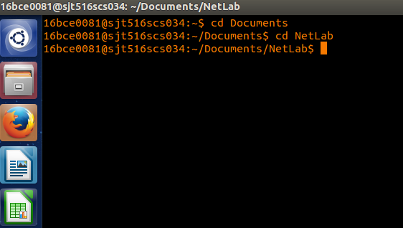

2. Command: mkdir
Description: create new directory
Syntax: mkdir Bunty
Output:

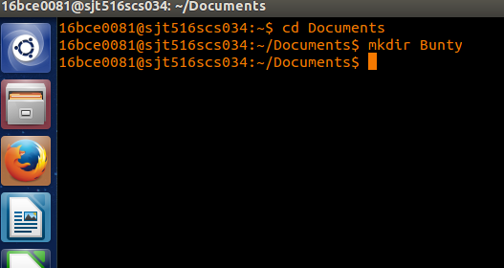

3. Command: rmdir
Description: remove empty directory (remove files first)
Syntax: rmdir Bunty
Output:

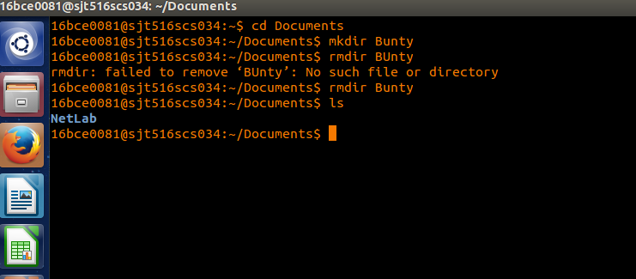
4. Command: mv
Description: change name of directory
Syntax: mv <Source> <Dest>

5. Command: pwd
Description: show current directory
Syntax: pwd

6. Command: date
Description: show date and time
Syntax: date

7. Command: history
Description: list of previously executed commands
Syntax: history

8. Command: cal
description: Prints a calendar for the specified month of
the specified year.
Syntax: cal <mon> <year>

9. Command: man
description: show online documentation by program name
Syntax: man <command>

10. Command: w
Description: who is on the system and what they are doing
Syntax: w

Outputs from 4 to 10

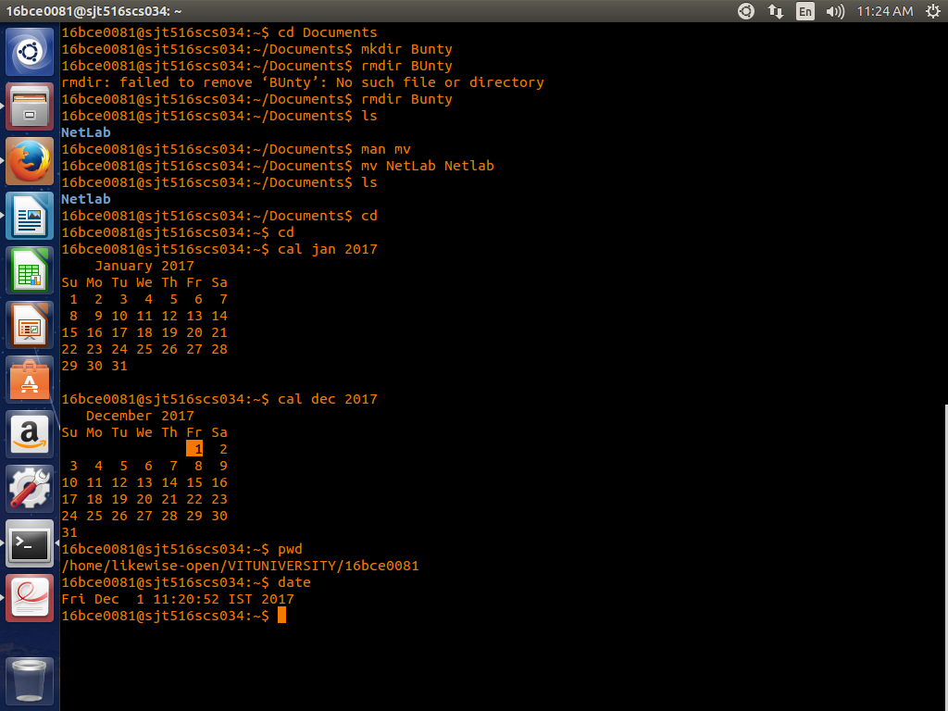

11. Command: whoami
Description: who is logged onto this terminal
Syntax: whoami

12. Command: uptime
Description; show one line summary of system status
Syntax: uptime

13. Command: tty
Description: know the terminal name
Syntax: tty

14.

